A Discrete Event Simulation For Modeling Of A
Dental Clinic

Jhon Ryan Alejo
BSCS-3E
Technological University of the Philippines - Manila
Manila City
jhonryan.alejo@tup.edu.ph
Wilfredo Casiño Jr.
BSCS-3E
Technological University of the Philippines - Manila
Biñan City
wilfredo.casinojr@tup.edu.ph
Kristian Jay Eusebio,
BSCS-3E
Technological University of the Philippines - Manila
Muntinlupa City
kristianjay.eusebio@tup.edu.ph

Ma. Kristina Joy G. Fidelino
BSCS-3E
Technological University of the Philippines - Manila
Parañaque City
makristinajoy.fidelino@tup.edu.ph

Abstract— Providing quality and time to take care of your teeth is the pinnacle of hygiene for most individuals. It would take mention of the dentist to achieve that goal of straightening and whitening your teeth, but due to the importance of having a good set of teeth, most teeth are either crooked or broken. Most individuals have to wait a long time or have to queue themselves to be taken care of, and the dental clinic would be the most convenient place to go through to get those procedures. It would be grueling and time-consuming to meet all those patients. The scope of this is to create a discrete event simulation to look after the patients' time to take for their appointment and be on service with the utmost care on a timely date.
Keywords— dental clinic, discrete event simulation, waiting time,

Introduction
Manufacturing was where discrete-event process simulation initially saw bright triumphs. Its use has increased in recent years to include analyses of supply-chain and warehousing operations, call centers, various service industries (such as hotels and retail establishments), public transportation (such as train lines and airport operation), government operations (such as the military and justice system), and the healthcare industry. Simulation has a very wide range of uses in the medical field, including emergency rooms, operating, recovery, and delivery rooms in hospitals, as well as clinics and the scheduling of nurses and anesthesiologists (including dental clinics).
With the Covid19 pandemic ongoing as of writing this paper, the speed at which you can get patients in and get them the treatment that they get before getting them out as soon as possible has become even more mandatory than normal. The team lead by Mirette Dube has published a paper regarding the study of using simulation systems to help prepare and manage the largest healthcare workforce and system in Canada (Dube et al., 2020) [1]. In the context of testing and integrating new procedures, workflows, and quick changes to practice (e.g., new cognitive aids, checklists, protocols), simulation has been shown to be crucial for both healthcare provider learning and systems integration. In our healthcare system, proactive simulation training is generating learnings at a volume and pace never before seen in terms of individuals, teams, and systems.
Due to the lack of staff at the dentist clinics to handle the many responsibilities, the researchers were asked to examine the current situation and make recommendations on ways that clinical workflows could be improved, in order to reduce the overall length of stay of said patients. As shown in this research, discrete-event process simulation was a useful and effective ally in attaining appreciable improvements in performance measures.
The remainder of this paper is organized as follows: Section 2 Proposed Methodology. Section 3 Experimental Method. Section 4 Results. Section 5 Conclusion

PROPOSED METHODOLOGY
A discrete event simulation method was developed to look after the outpatients in a dental clinic since they are increasingly keen to meet the needs of care in terms of dental health and has been recognized as one of the fundamental issues related to its service quality. One of the most important problems faced by outpatient dental clinics is the waiting time and the insufficient number of clinic staff to perform the various tasks. The simulation inputs are described in detail; conceptualization of patient flow in a typical dental clinic; and the three (3) flowchart simulations for different events in a dental clinic.

Input Analysis
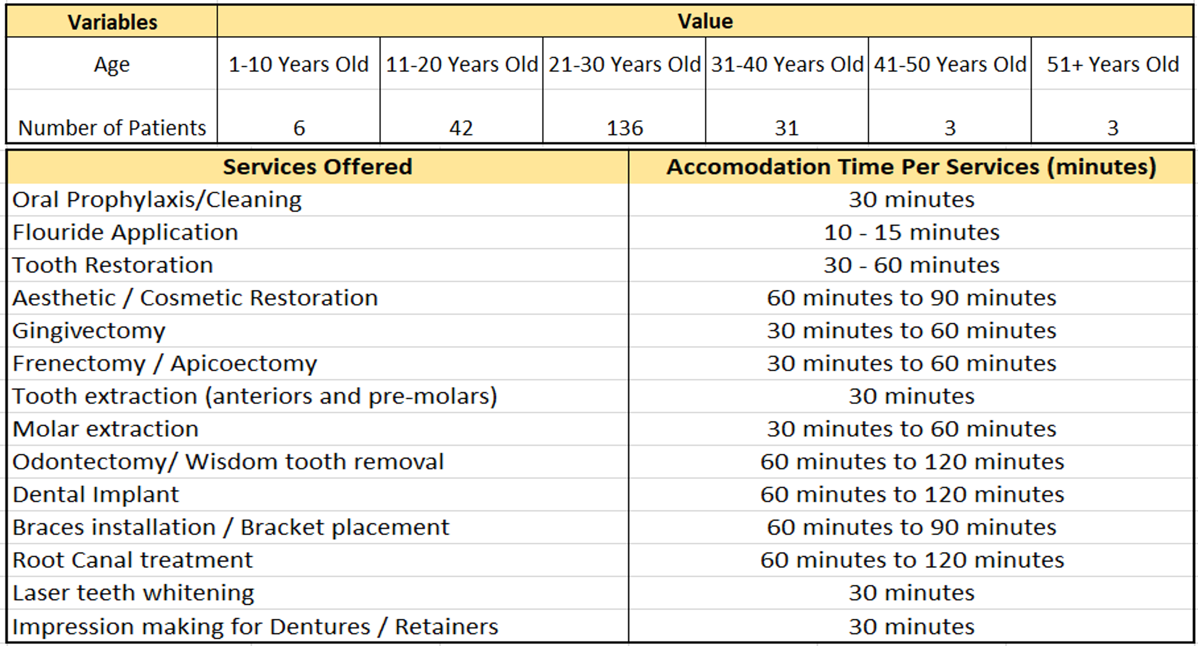
Table 1. Dental Clinic Data
A comprehensive data analysis was performed on a data set containing information about 221 patients from the month of March 2022. The number of patients visited, age of the patients, services offered, and the accommodation time per service (minutes) are the information that are derived from this data set and used as inputs to the DES model.

Discrete Model Conceptualization
Discrete Event Simulation (DES) is a method of simulating the behavior and performance of a process, facility, or system in real life during a certain time period, with changes in status variables occurring at discrete time points. To address the outpatient waiting time at a dental clinic, a data-driven DES model is developed using the Simio 14 simulation modeling program.
DES models can represent dynamic behaviors of real-world systems while accounting for significant degrees of uncertainty. In addition, DES models in the healthcare industry are frequently used to examine resource and staff utilization as well as estimate patient-related metrics (e.g., average length of stay and waiting time [wt]) under a variety of operational and physical limitations (Jun, Jacobson, & Swisher, 1999).

Flowchart of the Dental Clinic Simulation

Fig. 1. Patient Inquire Only Flow in the Dental Clinic

In Figure 1, the patient will first enter the clinic and then wait in the "waitingArea". After a couple minutes of waiting, the patient will proceed to the "frontDesk" and ask questions regarding the services that they offer, prices of the services, and so on, and this will be called "InquireOnly". If the patient doesn't want to proceed with any operations, they will now exit the simulation.

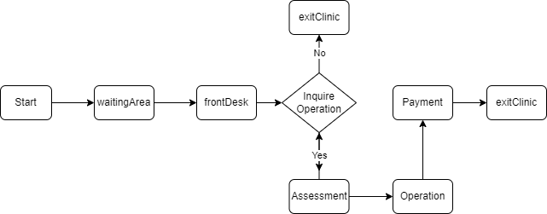

Fig. 2. Patient Inquiry and Operation Flow in the Dental Clinic

In this flowchart, the patient will enter the dental clinic and will start the simulation process. The patient will proceed to the lobby and wait, referred to as a "waitingArea". After waiting, the patient will proceed to the "frontDesk" and inquire with the person who is in charge. In this second figure, the patient has two options: first is if they inquire and didn't proceed to the operation, they will now exit the clinic and that will end the simulation process; the second option is when the patient inquires and they choose from one or more than one service offered by the clinic, the patient will now proceed to its "Assessment". The assessment refers to the checkup of the teeth, and after the assessment, the patient will proceed to the "Operations." After the operation, the patient will now go to the cashier to make their "payment". After all this process is completed, the patient will now exit the clinic, which will end the simulation process.

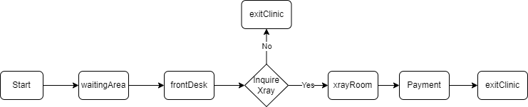

Fig. 3. Patient Inquire and X-Ray Flow in the Dental Clinic

In Figure 3, we still have two options. First, when the patient enters the clinic, they will proceed to the "waitingArea". They will now proceed to the "frontDesk" and inquire with the person in charge. If the patient only inquires and didn't choose to proceed to the X-ray, they will now exit the clinic and that will end the simulation. The second option is when the patient chooses to have an X-ray after their "inquiry". The patient will go to the "X-rayRoom" and after the procedure in the room, they will now go to the cashier to make their "Payment". After all the steps for the second option, the patient will now exit the clinic and the simulation process will end.

In a DES model, there are two essential variables to describe the characteristics of the simulation model. These are the time variables and the state variables. Although there is no agreed terminology in discrete simulation, we define the following terminology that we use based on Pidd's (2004) and divide it into two parts. The first part provides labels for the objects that constitute a system to be simulated. The second part is defined as the operations in which objects are engaged over time.
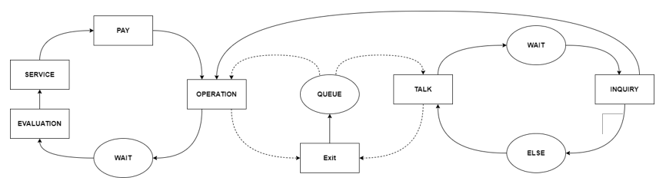
Fig. 4. Dental Clinic State Diagram

- Objects of the system
Entity: These are the individual system components that are simulated and whose activity is explicitly tracked. In our simulation are the "patients" from the dental clinic.

Resources: These are the system's component elements, although they are not modelled separately. They are treated as countable objects with no behavior tracking. Our resources for this simulation are the different "services offer" by the dental clinic.

- The Organization of Entities
The organization of entities is the entities that are grouped, whether they are permanent or temporary.
Classes: These are permanent groups of identical or similar entities. In this simulation, the classes are the "patients," the "cashier," and the "doctor".

Sets: These are temporary groups of entities that are often used to represent entity states or queues. The sets that we are using are the following:
- “WaitingAtLobby” - These are people who are waiting in a queue at a lobby.
- “WaitingToPay” – These are people who are waiting to pay at a cashier.
- “WaitingAtOperation” – These are people who are waiting to go to their dental operation

Attributes: these are items of information that belong to each entity, and they are used for: first use to distinguish between members of the same class entity; and second, to control the behavior of an entity. The "intended service the patient wants" is used as an attribute.

- Operations of the Entities.
During the simulation, the entities will cooperate, and thus they will change their state. There is some terminology that needs to be described here as well as the flow of time in the simulation.

Event: This is the instant of time where the significant state of the system changes. For this simulation, we have three events: first is when the patient only inquires; second is when the patient enters the dental clinic, inquires, and then proceeds for the operation; and lastly, when the patient inquires and proceeds only for their X-ray.

Activity: These are the entities that move from set to set where the operations are engaged. There are several activities used for each entity: Waiting for the "operation" Waiting for the assessment, Waiting at the lobby, Carry out an operation, paying at the cashier, Assessment of the teeth condition, getting personal information, inquiring about the person.

Process: This is often used to represent all or part of the life of temporary entities. In this simulation, the process is divided into three: first is "Inquiry", the second is for getting into "Operation", and lastly, proceeding to their "X-ray".

Simulation Clock: This refers to the point reached by the current simulated time in a simulation. In this simulation, we use the time unit "minutes," hence the test "is clock = 270 minutes."

Data Collecting
For the preparation of the dataset, data from the Dental Clinic is used for the month of March 2022. The overall data set consists of Four main categories of features.
- Demographic-category: Patient's Age
- Number of Patients per Day for the month of March
- Services Offered by the Dental Clinic
- Service Accommodation Time

Dental Clinic Discrete Event Simulation Model
Discrete event simulation (DES) is a kind of computer-based modeling that offers a simple and flexible way of expressing complex systems. It is used in various healthcare applications, and most of the early applications included analysis of resource-constrained systems. The general goal of DES was to improve the organization of the services provided. Nowadays, DES is increasingly used to evaluate specific techniques within the framework of health technology assessment.

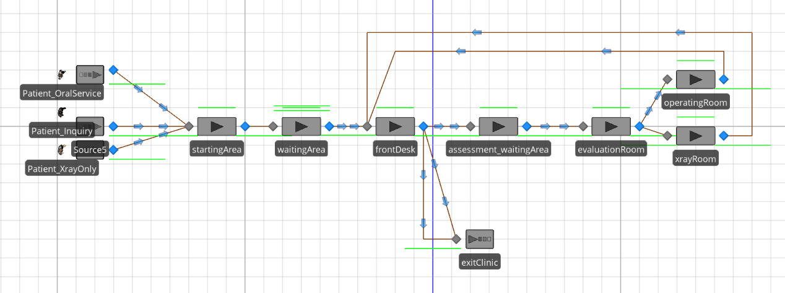

Fig. 5. Dental Clinic Discrete Event Simulation Model
Using the Simio14 simulation, we’ve created the simulation model for the dental clinic as shown in Figure 5.

Experimental Method

Experimental Setup
The SIMIO 14 Simulation Software is used to simulate
the Dental Clinic on a standalone Intel(R) Core(TM) i7-1075H CPU @ 2.60Hz, and 16.0 GB RAM with the Windows 10, 64-bit operating system.

Dataset
A real-world dataset of 221 patients' data was obtained from the Dental Clinic, consisting of 3 patient flowcharts, namely Patient Inquire Only Flow, Patient Inquiry and Operation Flow, and Patient Inquire and X-Ray Flow in the Dental Clinic, one demographic profile, and the service accommodation time.

Model Validation
The validity of the model was statistically tested using the TTEST and its P-value, the simulation for forecasting the arrival of the DES model coming from the historical dental patient cases of a dental clinic. The real dental patient data was provided by a dental clinic in Parañaque City in the month of March 2022. Other parameters for the simulation were set based on Table 1.

Results

Validation Results
We ran the model for 26 iterations since we based our simulation on data that was gathered in the month of March for all the flowchart of the dental clinic simulation. The historical data showed that the average number of patients was 14.7308 patients/day during March 2022. The simulated data shows 16.7692 patients per day. We validated the simulated data in the dental clinic against the real data using the statistical difference method.

Results Analysis
Here we use the TTEST to check the validity of the model with the real data versus the simulated data. To validate the data, the P-value(T<=t)one-tail and P-value(T<=t)two-tail should be greater than 0.05 to make it not significant. While the T-Test(1,1) should be less than 0.05 to make it not significant and valid.

T-Test (1,1) | 0.029577828
T-Test (1,2) | 0.048287228
Table 2. T-Test
The table 2, shows that the T-Test (1,1) shows a result of 0.02957783, which is not significant, which is why it is valid. For the T-Test (1,2), it shows a result of 0.04828723, which is also not significant and is valid.

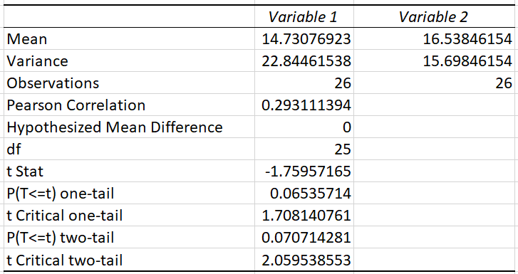
Table 3. t-Test: Paired Two Sample for Means
The table 3, shows the t-Test: Paired Two-Sample for Means between variable 1 (real data) and variable 2 (simulated data). The mean of the real data is 14.7307692 while the simulated data is 16.53846154. The variance value of the real data is 22.8446154 while the simulated data is 15.69346154. The value for the observation for both real data and simulated data is 26. The value of P(T<=t)one-tail is 0.06535714, which is not significant and valid. While the P (T= t) two-tail is also 0.07071428, which is not significant, it is valid.

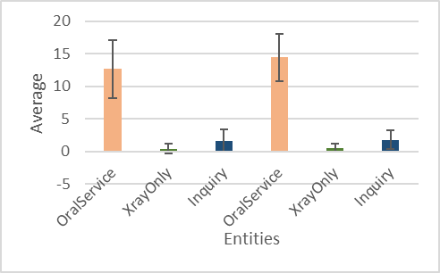
Figure 6. Average from Real Data vs. Simulated Data
In this figure, we compare the average of real data to simulated data using three (3) entities: OralService, XrayOnly, and Inquiry.

Conclusions
The study aims to develop a simulation to address the outpatient waiting time at a dental clinic and the service quality since they are keen to meet the needs of care in terms of dental health using the method of discrete event simulation.
Moreover, modeling with the Discrete Event Simulation (DES) methods has advantages and disadvantages. The simulation in the dental clinic can still be improved by using and experimenting with various modeling techniques and understanding the problem in detail since it is required to select the right and better model.

acknowledgement
This study, entitled "A Discrete Event Simulation for Modeling Of A Dental Clinic", was a part of a compliance in the subject CS363 Modeling and Simulation. We also want to thank Prof. Jan Eilbert Lee for his compassion, support, enthusiasm, and breadth of knowledge. His advice and discussion on some of the topics in this paper were a great help during the research and development of this concept.

REFERENCES

- Banks, C. M., & Sokolowski, J. A. (2010). Modeling and Simulation Fundamentals: Theoretical Underpinnings and Practical Domains (1st ed.). Wiley.
- Jun, J. B., Jacobson, S. H., & Swisher, J. R. (1999). Application of Discrete-Event Simulation in Health Care Clinics: A Survey. The Journal of the Operational Research Society, 50(2), 109.
- Karnon, J., Stahl, J., Brennan, A., Caro, J. J., Mar, J., & Möller, J. (2012). Modeling using discrete event simulation: a report of the ISPOR-SMDM Modeling Good Research Practices Task Force-4. Medical decision making: an international journal of the Society for Medical Decision Making, 32(5), 701–711.
- Mohamad, F., & Filza Saharin, S. (2019). Application of Discrete Event Simulation (DES) for Queuing System Improvement at Hypermarket. KnE Social Sciences.
- Pidd, M. (2004). Computer simulation in management science. Wiley.
- Y. Lu, Y. Guan, X. Zhong, J. N. Fishe and T. Hogan, "Hospital Beds Planning and Admission Control Policies for COVID-19 Pandemic: A Hybrid Computer Simulation Approach," 2021 IEEE 17th International Conference on Automation Science and Engineering (CASE), 2021, pp. 956-961.

